

# WEB TECHNOLOGY REPORT ON

**E-Banking System**

Submitted

In partial fulfilment requirements for the award of the Degree

Of

**BACHELOR OF ENGINEERING IN**

**INFORMATION SCIENCE AND ENGINEERING**

By

RACHANA 4NM17IS075

Staff Incharge

**Ms. Anusha N Assistant professor**

**Department of Information Science and Engineering**

**TABLE OF CONTENTS**

|  |  |  |
| --- | --- | --- |
| **Sl. No** | Title | **Page Number** |
| 1 | Introduction | 5 |
| 2 | Software Requirements | 5 |
| 3 | Proposed System | 5 |
| 4 | Source Code | 15 |
| 5 | Screenshots | 20 |
| 6 | Results and Future Scope | 21 |
| 7 | References | 21 |

**1)INTRODUCTION**

Introduction of Web Technologies Web Technology is a way of people communicating to other people through mark up language. It is a basic way of sharing information to the whole wide world. Here we use mark up language and scripting languages in order to share and attract people towards the presentation of the knowledge.

**Online banking**/**E-banking** allows a user to conduct financial transactions via the Internet. Online banking is also known as Internet banking or web banking.

Online banking offers customers almost every service traditionally available through a local branch including deposits, transfers, and online bill payments. Virtually every banking institution has some form of online banking, available both on desktop versions and through mobile apps.

This project using HTML 5, CSS to design the front end of the website. Java script is used in this project to make the project interactive.

**2)PROJECT REQUIRMENTS**

**SOFTWARE REQUIRMENTS**

* Programming language: HTML
* Style Sheets: CSS
* Editor :Sublime Text

**HARDWARE REQUIRMENTS**

* System having enough space to have editor installed.

**3)IMPLIMENTATION**

This E-banking website is a simple website which has a main page with “signup/sign-in” page, personal services, facilities available and about us in the navigation bar. Signup/sign-in page is to login or to sign up for a new customer.

When “Personal” services is clicked, it’ll take to the basic transaction page, which has basic transactions like check balance, send money, withdraw and deposit.

If “Facilities” is chosen, it has features like loan application, card application and account types with application form to apply for those.

Finally the “About us” page gives a brief description about the entire website, contact information, help, all other facilities, their branches located.

**4)CODE**

Main1.html:

<!DOCTYPE html>

<html>

<head>

<title>Main</title>

<link rel="stylesheet" type="text/css" href="style.css">

</head>

<body>

<div id="main">

<nav>

<img src="img.png" width="200" height="80">

<ul>

<li><a href="login1.html">Signin/SignUp</a></li>

<li><a href="personal1.html">Personal</a></li>

<li><a href="facilities.html">Facilities</a>

<li><a href="aboutus.html">About Us</a></li>

</ul>

</nav>

</div>

</body>

</html>

Login1.html:

<!DOCTYPE html>

<html>

<head>

<title>Login</title>

<link rel="stylesheet" type="text/css" href="style.css">

</head>

<body>

<div class="sign-up-form">

<h1>Sign up</h1>

<form>

<input type="text" class="input-box" placeholder="username" name="username">

<input type="password" class="input-box" placeholder="password" name="password">

<p><span><input type="checkbox"></span>I Agree to terms and conditions</p>

<button type="submit" class="sign-btn"><a href="main1.html">Sign In</a></button>

<hr>

<form>

<p class="or">OR</p>

<p align="center">Dont have an account ?</p>

<button class="sign-in"><a href="signup.html" input type="submit" >Sign Up</a></button>

</form>

</form>

</div>

</body>

</html>

Personal1.html:

<!DOCTYPE html>

<html>

<head>

<title>Accounts</title>

<link rel="stylesheet" type="text/css" href="personal1.css">

<script type="text/javascript">

function togglemenu(){

document.getElementById('sidebar').classList.toggle('active');

}

</script>

</head>

<body>

<div id="sidebar" onclick="togglemenu()">

<div class="toggle-btn">

<span></span>

<span></span>

<span></span>

</div>

<ul>

<li><a href="xyz3.html">CHECK BALANCE</a></li>

<li><a href="xyz.html">WITHDRAW</a></li>

<li><a href="xyz1.html">DEPOSIT</a></li>

<li><a href="xyz2.html">SEND</a></li>

</ul>

</div>

<br>

<form>

<p align="right"><input type="button" value="Go Back!" onclick="history.back()"></p>

</form>

</body>

</html>

Facilities.html:

<!DOCTYPE html>

<html>

<head>

<title>facilities</title>

<link rel="stylesheet" type="text/css" href="facilities.css">

</head>

<body>

<div class="wrapper">

<ul>

<li>Accounts

<ul>

<li>Savings</li>

<li>Current</li>

<li>Recurring deposit</li>

<li>fixed Deposit</li>

</ul>

</li>

<li>Cards

<ul>

<li>Atm</li>

<li>Debit</li>

<li>Credit</li>

</ul>

</li>

<li>Loans

<ul>

<li>Unsecured</li>

<li>Secured</li>

<li>fixed rate</li>

<li>variable</li>

</ul>

</li>

</ul>

</div>

<button align="left" ><a href="application.html" input type="submit" >Apply here</a></button>

</body>

</html>

AboutUs.html:

<!DOCTYPE html>

<html>

<head>

<title>About us</title>

<link rel="stylesheet" type="text/css" href="aboutus.css">

</head>

<body>

<div class="container">

</div>

</body>

</html>

AboutUs.css:

body{

margin:0;

padding:0;

height:100%;

width:100%;

}

.container{

height:100vh;

width:100%;

background-image:url(2.png);

background-size:cover;

background-position:center;

background-repeat:no-repeat;

transition:10s;

animation-name: animate;

animation-direction:alternate-reverse;

animation-duration:30s;

animation-fill-mode:forwards;

animation-iteration-count:infinite;

animation-play-state:running ;

animation-timing-function:ease-in-out ;

}

@keyframes animate{

0%,100%{

background-image: url(2.png);

}

25%{

background-image: url(3.png);

}

50%{

background-image: url(4.png);

}

75%{

background-image: url(5.png);

}

}

Facilities.css:

.{

margin:0;

padding:0;

}

body{

background-image:url(facility.jpg);

-webkit-background-size:cover;

background-size:cover;

background-position:center center;

height:100vh;

}

.wrapper{

width:860px;

margin:0 auto;

}

.wrapper ul{

list-style:none;

margin top:2%;

}

.wrapper ul li{

background:#000;

width:170px;

border:1px solid #fff;

height:50px;

line-height:50px;

text-align:center;

float:left;

color:#fff;

font-size:14px;

position:relative;

font-family:big john;

}

.wrapper ul li:hover{

background:crimson;

}

.wrapper ul ul{

display:none;

}

.wrapper ul li:hover >ul{

display:block;

}

Personal1.css:

*{

margin:0;

padding:0;

}

#sidebar{

position:fixed;

width:20%;

height:100%;

left:-20%;

background-color:black;

}

#sidebar li{

color:white;

font-size:30px;

padding:30px;

border-bottom:1px solid gray;

text-align:center;

}

.toggle-btn{

position: absolute;

left:105%;

top:15px;

}

.toggle-btn span{

display:block;

background-color:black;

width:30px;

height:5px;

margin:3px;

}

#sidebar.active{

left:0;

}

body{

margin: 0;

padding: 0;

font-family: sans-serif;

background-image: url(download.jpg);

background-size:cover;

background-position: center top;

background-attachment:fixed;

}

**5)SCREENSHOTS**



**Fig1:** Displays the main page

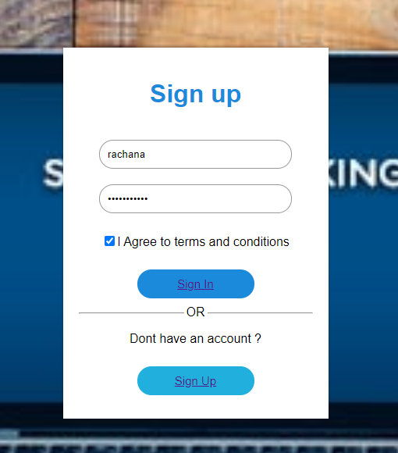

Fig2: Displays signup and sign in page

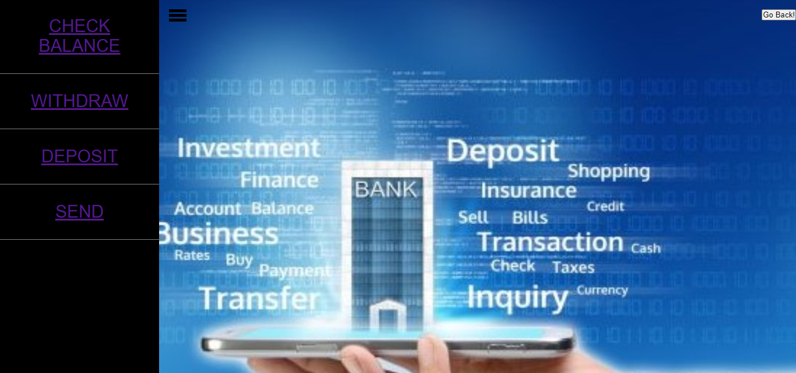

Fig 3. Displays personal.html with different transaction options.

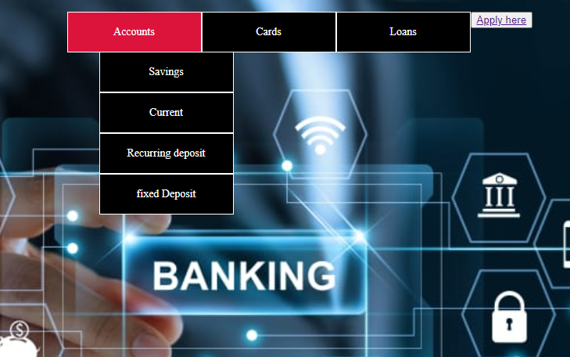

Fig 4: Displays facilities.html with different facilities available by bank.

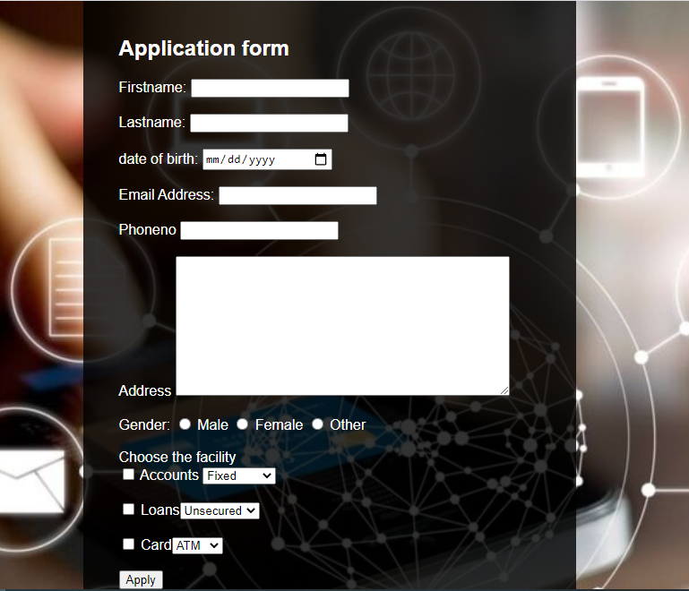

Fig 5: Displays application form to apply.

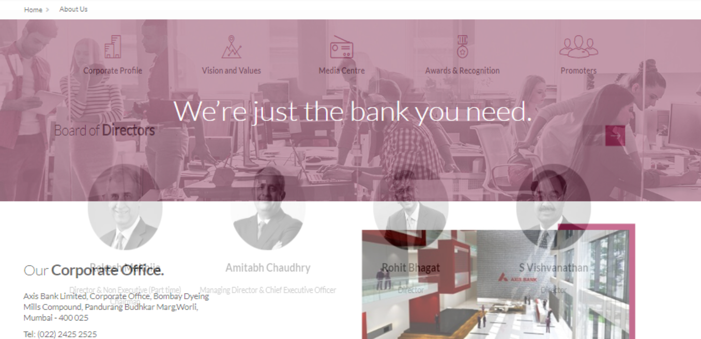

Fig 6: Displays a transitioning about us page.

**7)CONCLUSION**

User interface provided is quiet user friendly and simple. This project doesn’t have all features required for a E-banking website. There are many other facilities available these days, like e-wallets, shopping , m-pesa , paga , digital money, which can be included in the future. Also the safety and security of this website has to be secure and improvised, as that’s the most important thing of banking applications.